Phenols, aldehyde, and secondary amine condensation as an application of mannich reaction mechanism
تكاثف فينول ، ألدهيد ، أمين ثانوي كتطبيق ميكانيكية تفاعل مانيش
By
Radada
رداد حمود محمد علي الريمي

Directed by
Prof. Xiang Zhou
Dr. Xiaocheng Weng

College of Chemistry and Molecular Sciences
Wuhan University
May, 2011

ملخص
تكاثف كيتون أو فينول والدهيد و امين ثانوي كتطبيق ميكانيكية تفاعل مانتش
الباب الأول مقدمة :
تفاعل مانتش يستخدم لتصنيع أنواع كثيرة من المركبات و أيضا مفيد في تصنيع المركبات المحتوية على النيتروجين
الباب الثاني :التصميم:
إنا صنعت هذه المركبات لان فيها فوائد تصنيعية وطبية عديدة وممكن تستخدم لأغراض دوائية ومنتجات طبية.
ميكانيكية مانتش:
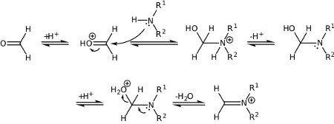
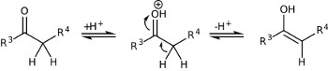
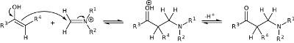

الباب الثالث:التجارب:

الإجراء العام المركب الأول :1.08جرام فينول 0.6جرام الهيد 1.1جرام أمين ثانوي تمزج معا في إناء حجم 50مل لمدة يوم في الإيثانول
الإجراء العام المركب الثاني :4.3جرام فينول 2.4جرام الدهيد4.4جرام أمين ثانوي تمزج معا في إناء حجم 50مل لمدة يوم في الإيثانول

الباب الرابع:النتائج:
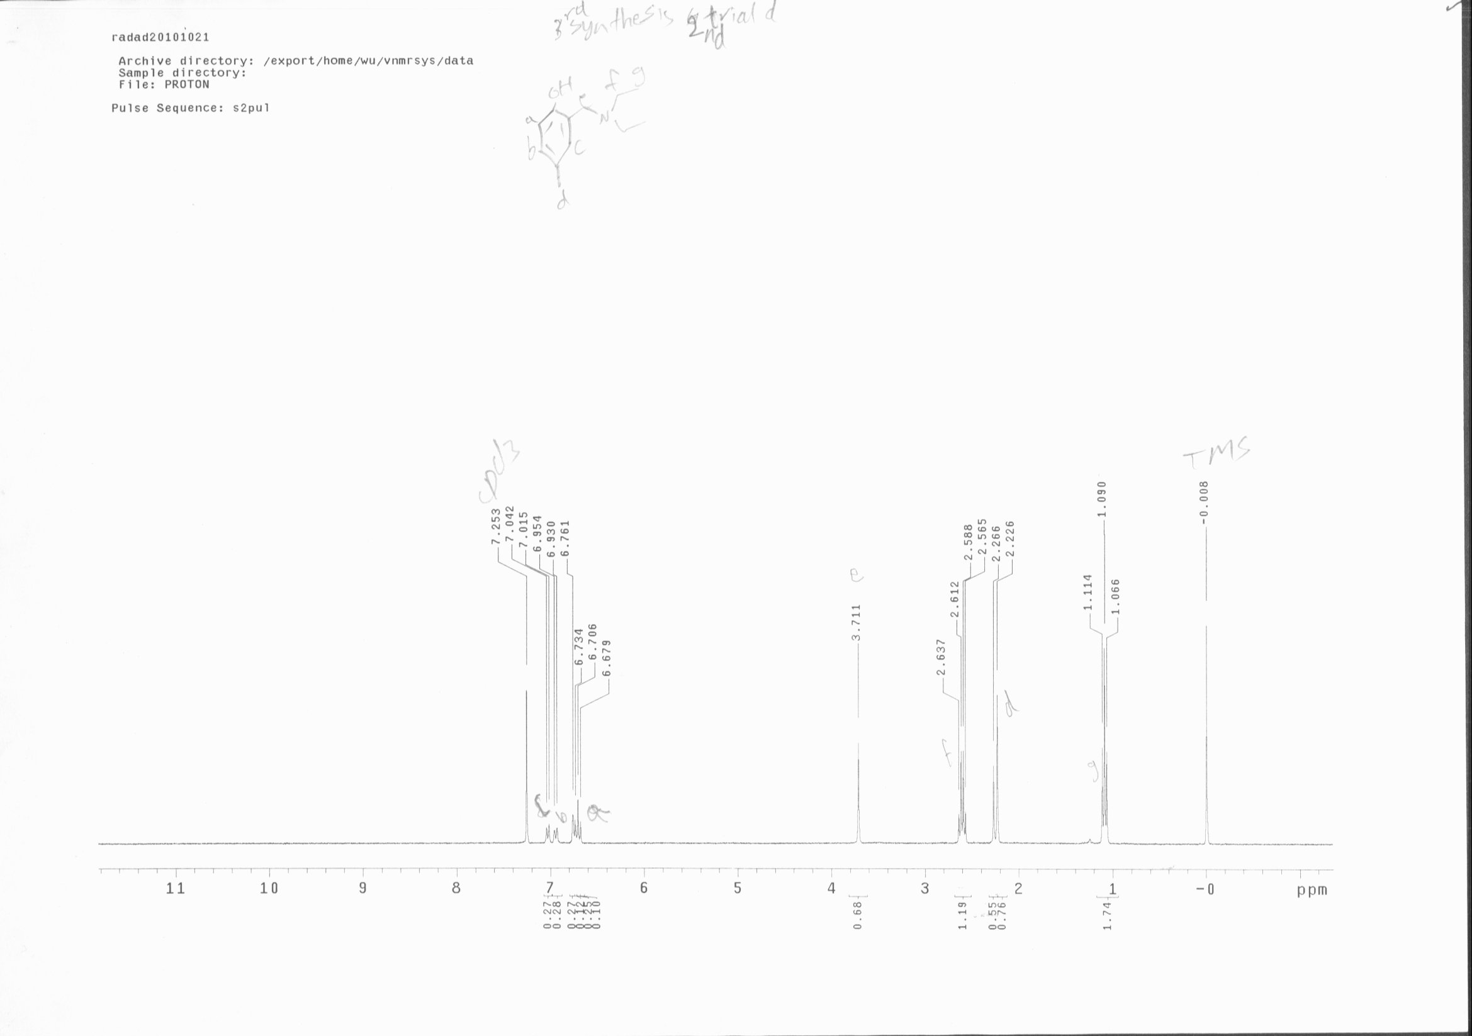

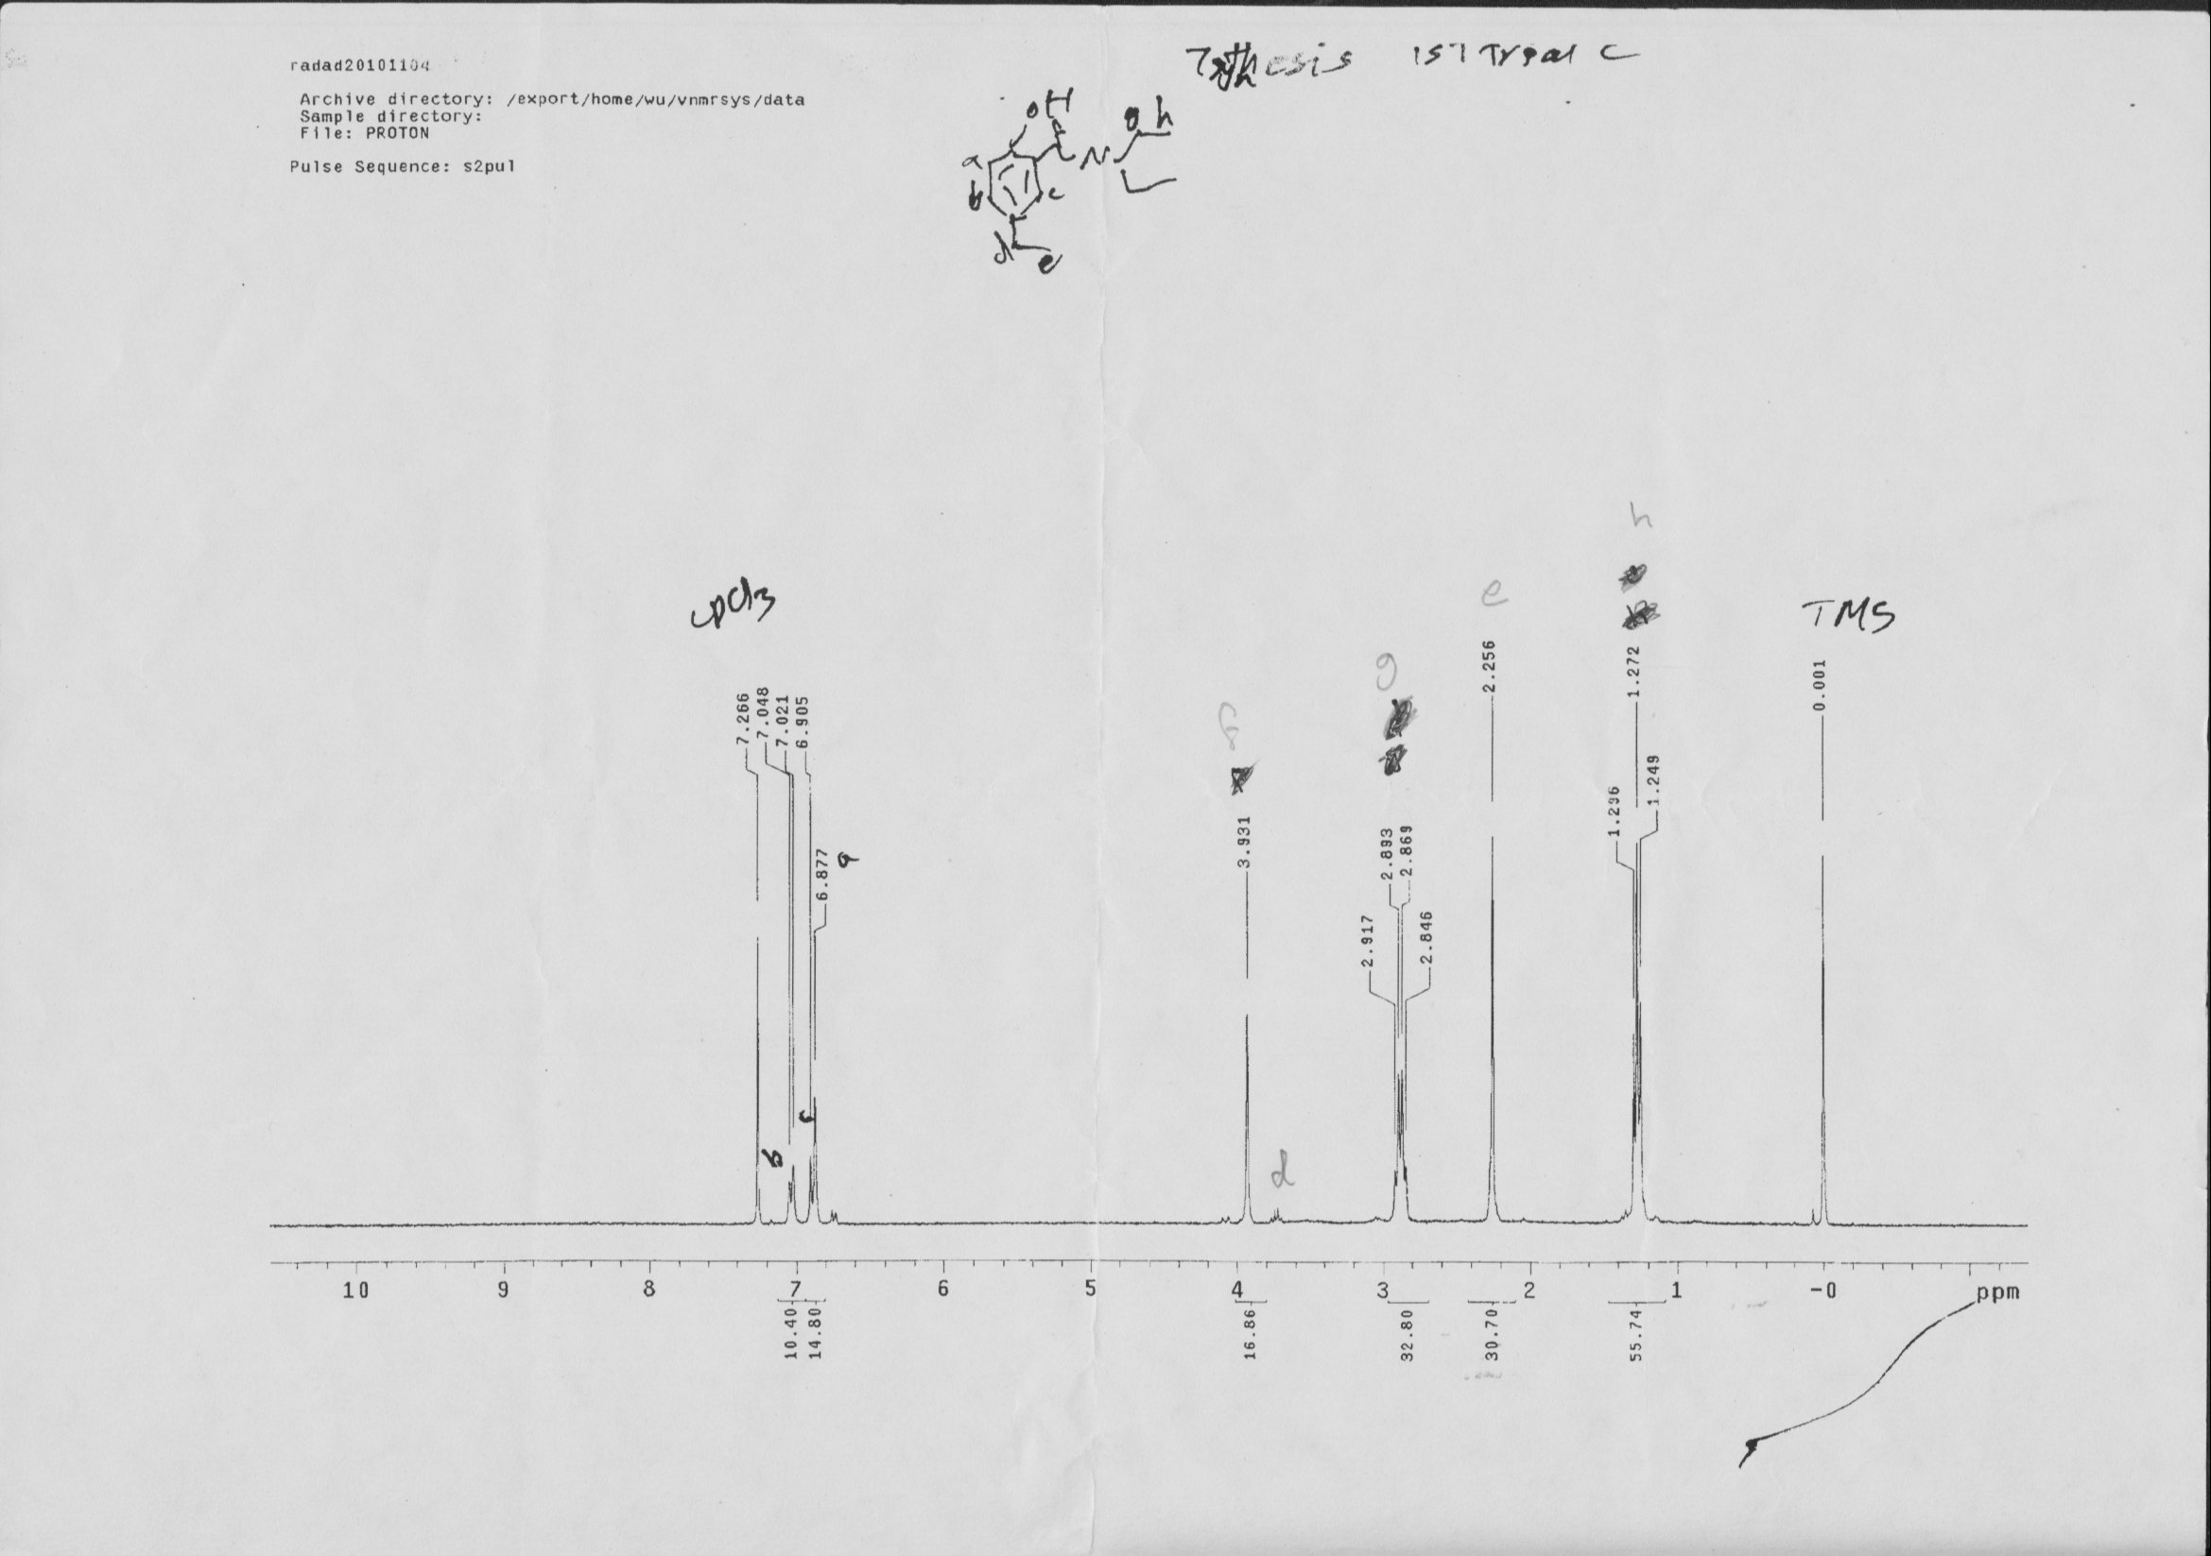
الباب الخامس :الاستنتاج:
أنا اكتشفت إن ميكانيكية تفاعل مانتش ذو الثلاث المكونات يمكن تطبيقها إذا كنت دقيق في الحسابات الكيميائية كالحرارة والكتلة والوزن الجزيئي وتحويل الوحدات وكذلك إذا كنت دقيق في عملية الفصل واخترت المذيب المناسب

Abstract
Chapter1:

Mannich reaction is widely used for the synthesis of many kinds of compounds1. In the synthesis of the derivatives of Mannich base phenol derivatives, a one-pot method is used, in which ketone, secondary-amine, aldehyde are refluxed together in alcohol2,3 .
The Mannich reaction, on the other hand, is synthetically useful
for the construction of nitrogen-containing molecules.3
Chapter2:
Examples of Mannich Three Component Condensation:
Example1:A New Investigation of Mannich Reaction
Mannich reaction is widely used for the synthesis of many kinds of compounds1. In the synthesis of the derivatives of styryl ketonic Mannich bases, a one-pot method is used, in which ketone, secondary-amine hydrochloride, paraformaldehyde are refluxed together in alcohol2’3. In most cases the normal Mannich product MA is obtained. But when certain amine is used as the reactant, a side-product IM, instead of MA is obtained. MS and 1HNMR data indicate that compound IM is a new type of Mannich base which has a terminal double bond at -position of the ketone group. The result of pharmacological screening showed that IM was a better anticancer agent than corresponding normal product MA. Therefore the reaction is further investigated for extending the range of this type of reaction.
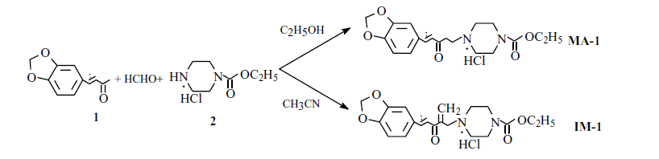
Using the same reactants 1 and 2, they compared several conditions for investigation of the formation of compound IM. The results showed that the acidity, concentration of the ketone and amine, solvent type are the crucial factors as shown in the Table 1,2,3.
Acidity: After trying several pH values, we found that pH 4.5 - 5.0 was the most favorable acidity for the formation of IM. If the pH≤4.5 the mixture of MA-I andIM-1 was obtained. If the pH was lowerd to 3.0, the only normal Mannich base was obtained. If the pH was higher than 6, the formation of both MA and IM was restrained (Table 1).
Table 1 The effects of pH on the orientation of Mannich reaction*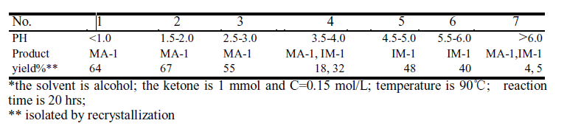Concentration: In the same reaction condition, when the concentration of the ketone and amine were 0.1~0.15 mol/L. MA-1 was the main product, while the concentration of the ketone and amine were 0.6 mol/L. The only product was IM-1.
(Table 2).
Table 2 The effects of concentration on the orientation of Mannich reaction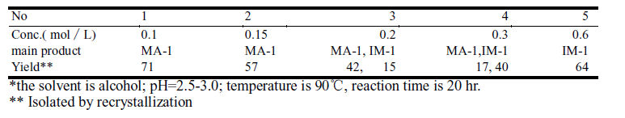Solvent type: Fixing other reaction conditions, we changed the solvent of reaction and found, that in alcohol the most product was MA-1, but it was contaminated withIM-1 and difficult to separated. Then we tried other solvents such as ClCH2CH2Cl,THF and CH3CN, etc. Among these CH3CN was found to be the most ideal solvent for the formation of product IM. (Table 3).
Table 3 The effect of solvent type on the orientation of Mannich reaction*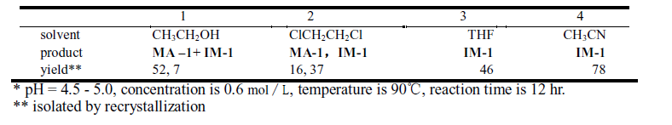
That the reactivity of ketones for this type of reaction are different. Generally speaking, the ketones with the electron-drawing groups are more active than those with the electron-donating groups. Further work is in progress.
The normal Mannich product MA was usually formed at first as shown on the TLC.
When the reaction time was prolonged, the amount of MA reduced and the product IM developed more and more. At the same time, other impurities also increased. So twopossible mechanisms for the formation of compound IM were proposed (Scheme 1).
First, compound IM maybe formed by the further hydroxymethylation of the normal product MA and subsequent dehydration. Second, compound IM may be formed by the deamination of the diamine B.
Scheme 1 Possible mechanisms of the formation of compound IM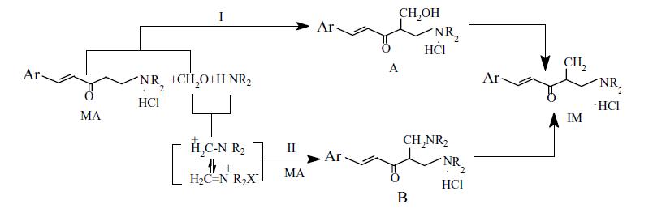-chemists mixed the product MA with paraformaldehyde without the ammonium salt, the expected product IM was obtained. When deuterium labelled paraformaldehyde was used, the obtained compound IM was also deuterium labelled at the terminal methylene group, this result agreed with the first mechanism and proved the first mechanism to be possible.
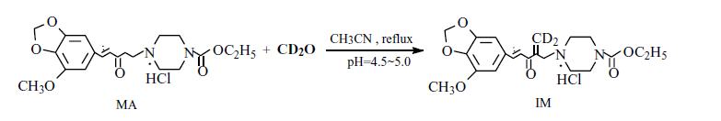 α.β.Unsaturated ketone can be obtained by the deamination of normal Mannich bases4. Compound MA which has a carbonyl group and theα-protons which can reacted with paraformaldehyde and amine further to proceed the second Mannich reaction. Several methods have been tried to synthesize the diamine B, but only a small amout of IM was obtained instead of diamine B. This fact indecated, that the mechanism of formation of IM also could be considered through deamination of diamineB. Because of the diamine B was very unstable, so it was difficult to be defected.

Example2:Mannich-Type Reactions of Aldehydes,
Amines, and Ketones in a Colloidal
Dispersion System Created by a
Brønsted AcidSurfactant-Combined Catalyst in Water
Recently, organic synthesis in water has received much attention, not only because unique reactivity and selectivityare often exhibited in water but also because it is an economical and environmentally benign solvent. 1However, one major disadvantage in the use of water as a solvent is that most organic compounds are insoluble in water and, as a result, most reactions are slowed. To circumvent this disadvantage, surfactants, which solubilize organic materialsor form colloidal dispersion with them in water, have been used. However, only a limited number of practical examples of surfactant-aided organic reactions have been reported to date.2 On the other side, chemists have recently developed surfactant-aided Lewis or Brønsted acid-catalyzed reactions in water. In these reactions, a catalytic amount of a Lewis acid-surfactant-combined catalyst (LASC) such as scandium tris(dodecyl sulfate)3c-f or a Brønsted acid-surfactant combined catalyst (BASC) such as dodecylbenzenesulfonicacid (DBSA)3g acts both as an acid catalyst to activate a substrate and as a surfactant to form stable colloidal dispersion with water-insoluble substrates. These catalysts have been successfully applied to aldol,3c-f allylation,3f and Mannich-type reactions.Mannich and related reactions provide one of the most basic and useful methods for the synthesis of β -amino. carbonyl compounds, which constitute various pharmaceuticals,natural products, and versatile synthetic intermediates.4 Conventional protocols for three-component Mannich-type reactions of aldehydes, amines, and ketones in organic solvents include some severe side reactions and have some substrate limitations, especially for enolizable aliphatic aldehydes. The previous DBSA-catalyzed three-component Mannich-type reactions in colloidal dispersion systems,3g in which silyl enolates instead of ketones are used as nucleophilic components,5 have extended the substrate applicability and avoided the use of organic solvents. However, there is still a drawback in that the silyl enolates have to be prepared from the corresponding carbonyl compounds usually under anhydrous conditions. From atom economical and environmental points of view, therefore, it is desirable to develop a new efficient system for Mannich-type reactions in which the parent carbonyl compounds are directly used 6 and water is used as a solvent

(Scheme 1). These three-component. reactions would be also useful for the synthesis of β-aminoketone libraries.7 Here i report DBSA-catalyzed three component Mannich-type reactions in a colloidal dispersion system using ketones as nucleophilic components.
The reaction of benzaldehyde, aniline, and acetophenone in the presence of an acid catalyst in water was selected as a model reaction. Among the Brønsted and Lewis acid catalysts tested, DBSA 8 catalyzed the reaction most efficiently(Table 1, entry 1).

Interestingly, this efficient. catalysis was not observed in the reactions carried out in organic solvents such as MeOH and CH2Cl2. This solvent effect shows the unique property of water to induce hydrophobic interactions between the substrates and the catalyst. Scandium tris(dodecyl sulfate), a representative LASC, was less effective than DBSA (entry 2). It should be noted that p-toluene sulfonic acid (TsOH) did not afford the desired product (entry 3). DBSA formed a white turbid reaction mixture, while TsOH formed two immiscible layers..
This result indicates that the long alkyl chain of DBSA is necessary for formation of the colloidal dispersion which leads to efficient catalysis. In fact, a combination of TsOH and sodium dodecyl sulfate (SDS), which formed a colloidal dispersion in the presence of the substrates, afforded the adduct in a modest yield (entry 5), while SDS alone gave the adduct in a very low yield (entry 4). The reaction proceeds through the imine formation of the aldehyde and the amine, protonation of the imine, and the attack of the enol derived from the ketone to the protonated imine. This dehydrative imine formation in water is a characteristic feature of the colloidal dispersion system for reactions of imines.
The reactions of various aldehydes, amines, and ketones were found to be efficiently catalyzed by DBSA at ambient temperature in water (Table 2).9,12 The following features are noteworthy in these reactions..
(1) A 1:1:1 mixture of benzaldehyde, p-anisidine, and acetophenone with 10 mol % of DBSA gave the Mannich adduct in 63% yield (entry 1), in contrast to a 30% yield by a conventional HCl-catalyzed reaction in EtOH (18 h).6a (2)In the case of the substrates shown in entries 3, 5, and 6,only 1 mol % of DBSA was sufficient to catalyze the reactions. (3) The reactivity order of the amines is pchloroaniline> aniline > p-anisidine, indicating the importance of the electronic nature of the amines. (4) In the reaction of 2-butanone (entry 8), the adduct aminoalkylated at the less substituted R-carbon was formed preferentially.
(5) Not only benzaldehyde but also heteroaromatic aldehydes such as 2-furfural and 2-pyridinecarbaldehyde worked well(entries 9 and 10). (6) For enolizable aliphatic aldehydes such(

.as isovaleraldehyde, the reaction procedure mentioned above afforded a complicated mixture of various compounds probably due to self-condensation of the aldehyde. Therefore, chemists tried slow addition of the aldehyde to a mixture of an amine, a ketone, and DBSA in water. Indeed, this procedure greatly improved the yields up to 71% (entries 11 and 12).
(7) For the reactions of cyclohexanone, cycloheptanone, and 2-butanone, 5 equiv of the ketones was needed to avoid polyaminoalkylation.
In summary, three-component Mannich-type reactions of aldehydes, amines, and ketones are efficiently catalyzed by DBSA in water. Aromatic, heteroaromatic, and aliphatic aldehydes can be successfully used as the aldehyde component.
Moreover, these reactions, which proceed sluggishly in organic solvents, attest to the unique property of water as a reaction medium. DBSA forms stable colloidal particles in the presence of the substrates in such a medium, and this colloid formation plays an essential role in acceleration of the reactions. Although organic reactions in water are still at a preliminary stage, the colloidal dispersion systems will provide a promising method for practical synthetic reactions in water.
have been reported earlier. The spectral data for the other Mannich adducts

. Example3:Application of High Pressure Induced by Water-Freezing to the Direct Catalytic Asymmetric Three-Component List-Barbas-Mannich Reaction
High pressure is one of the factors that can effectively accelerate many organic transformations,1 although its use in organic synthesis is rather limited owing to the necessity for special high-pressure apparatus. A new and easy method for generating high pressure is desirable. Chemists have been investigating the novel method of high pressure induced by water-freezing, in which the high pressure (ca.
200 MPa) is easily achieved simply by freezing water (-20 °C) in a sealed autoclave.2 The Michael reaction of alcohols with , α-β enones 2a and the Baylis-Hillmann reaction 2b have been effectively accelerated by this high pressure.
The Mannich reaction, on the other hand, is synthetically useful for the construction of nitrogen-containing molecules.3 Recently many excellent results have appeared describing catalytic asymmetric variants of this reaction,4-6 among which is an elegant,asymmetric, three-component Mannich reaction catalyzed by praline reported independently by List4 and Barbas.5 Despite the high enantioselectivity, there are limitations to List’s reaction: Yields are generally insufficient when acetone is used as the Mannich donor, while the Mannich acceptor should be electron-deficient and highly reactive.In this communication, i describe how the newly developed,high-pressure method has been applied to the List-Barbas-Mannich reaction, in the expectation that the effects of both high pressure and low temperature would play pivotal roles, that the yield and enantioselectivity would be improved due to the negative activation volume of the three-component coupling reaction and the lower temperature, respectively.
The Mannich reaction of p-bromobenzaldehyde, p-anisidine, and acetone was investigated under high-pressure induced by water freezing,and it was found that the Mannich and aldol adducts were obtained in 57% yield with 95% ee, and in 11% yield with 78%ee, respectively.7 When the same reaction was performed under ambient pressure at room temperature, the reaction proceeded slowly, affording the Mannich adduct in 25% yield with 88% ee,the aldol product in 10% yield with 74% ee, and 4-(p-bromophenyl)-3-butene-2-one, the dehydrated product, in 12% yield.
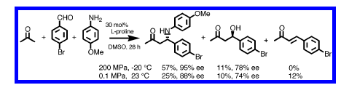 As the reaction under high pressure gave the Mannich productin better yield and enantioselectivity without concomitant formation of the , α- β enone, the present high-pressure method has been applied to other aldehydes to investigate the generality of the reaction, the results being summarized in Table 1. As some of the Mannich Table 1. Mannich Reaction of Various Aldehydes, p-Anisidine,and Acetone Catalyzed by L-Proline under Ambient Pressure and High Pressure Induced by

Water-Freezing . a The molar ratio of aldehyde:p-anisidine:L-proline ) 1:1.1:0.3, DMSO was used as solvent. b Isolated yield. c Data of ref 4b. d The yield of the Mannich adduct. e The two-step yield of the amino alcohol derived from LiAlH4-reduction of the labile Mannich adduct.
adducts are prone to racemize during purification, they were isolated as the corresponding amino alcohols after reduction with LiAlH4.
For electron-deficient aldehydes such as p-nitro- and p-bromobenzaldehydes, the yield at room temperature under 0.1 MPa is only 20-25%, while it is 57-58% under water-freezing high pressure conditions, when the optical purity is 91-95% ee (entries2-6). At low temperature (-20 °C) under 0.1 MPa, the reaction proceeds very slowly, affording only a minute amount (5%) of the Mannich adduct in very high optical purity (98% ee) (entry 3).
These results clearly indicate that high pressure decreases the optical purity 8 but increases the reaction rate, while lowering the temperature decreases the reaction rate but increases the optical purity in the reaction of p-nitrobenzaldehyde.
The reactions of benzaldehyde, and 1- and 2-naphthaldehydes under water-freezing high-pressure conditions afford Mannich adducts in good yield (64-99%) with excellent enantiomeric excess(91-93% ee), in marked contrast to the reaction at room temperature under 0.1 MPa, in which low yields (12-15%) and decreased enantioselectivity (79-89% ee) are obtained (entries 7-13).
For electron-rich aldehydes, both yield and optical yield are low at room temperature under 0.1 MPa, and in particular, no reaction proceeds in the cases of p-anisaldehyde, 3,4-dimethoxybenzaldehyde,and N-acetyl-(4-formyl)aniline, while good yields (61-99%)and excellent enantioselectivities (92-97% ee) have been realized under water-freezing high-pressure conditions (entries 14-24).
Higher temperature (40 °C) had no beneficial effect either on yield or enantioselectivity as the Mannich product of p-anisaldehyde was obtained in only 20% yield with lower enantiomeric excess (54%ee), along with several unidentified products (entry 19), while the Mannich adduct was obtained quantitatively and in 94% ee (entry20), without any byproducts under the high-pressure conditions.
2-Furalaldehyde and aliphatic aldehydes such as cyclohexylcarbaldehyde also react under water-freezing high-pressure conditions to give Mannich adducts in good yield and high optical purity(entries 25-28).
Generally a small amount of ,α-β enone product was observed at ambient pressure, which was not formed at high pressure.
The predominant enantiomer formed is the same irrespective of pressure, and its absolute stereochemistry is expected to be the same as that determined by List and Barbas .4,5 Next 4-tert-butyldimethylsiloxyaniline was employed instead of p-anisidine, because this N-substituent can be easily removed under mild oxidative conditions. 4-tert-Butyldimethylsiloxyaniline reacts even with highly electron-rich, unreactive, 3,4-dimethoxybenzaldehyde,affording the Mannich adduct with the same efficiency as does p-anisidine. After reduction with LiAlH4, protection of the hydroxyl group with TIPSOTf and 2,6-lutidine and separation of the anti- and syn-isomers, the tert-butyldimethylsiloxyphenyl moiety could be removed by the recently developed method using PhI-(OCOCF3)2 9 to afford the 1,3-amino alcohol, without affecting the electron-rich 3,4-dimethoxyphenyl moiety, while oxidative removal with CAN or DDQ gave complex mixtures.10 As selective reductions of 1,3-aminoketones to both syn- and anti-1,3-amino alcohols are known,11 the present procedure is one practical method for the preparation of chiral 1,3-amino alcohols with either syn- or anti stereochemistry.
In summary, the water-freezing induced-pressure method widens the scope and generality of the List-Barbas-Mannich reaction,giving both better yield and enantioselectivity, the increases of yield and optical purity being due to the high pressure and low temperature, respectively. High pressure and low temperature are both essential for the success of this asymmetric catalytic reaction;the former not only accelerates the reaction but also suppresses side reactions such as the formation of α-β enone. An especially noteworthy feature is that electron-rich, aromatic aldehydes, unreactive substrates under ambient pressure, can be successfully employed, affording the product in good yield. Moreover, by using 4-tert-butyldimethylsiloxyaniline, removal of the N-substituent can be successfully performed without affecting any other oxidatively labile, electron-rich aromatic groups, affording the syn- and anti-1,3-amino alcohols, both of which are synthetically useful, in high optical purity. Its high yield, excellent enantioselectivity, and operational simplicity, combined with the availability and low cost of the catalyst as well as the
Example4:Highly Efficient One-Pot Three-Component Mannich Reaction in Water Catalyzed by Heteropoly Acids:
Carrying out organic reactions in water has become highly desirable in recent years to meet environmental considerations.1
The use of water as a sole medium for organic reactions would greatly contribute to the development of environmentally friendly processes. Indeed, industry prefers to use water as a solvent rather than toxic organic solvents.
In this context, in recent years, much attention has been focused on Lewis acid catalyzed organic reactions in water.
Heteropoly acids (HPAs) are environmentally benign and economically feasible solid catalysts that offer several advantages.2 Therefore, organic reactions that exploit heteropoly acid catalysts in water could prove ideal for industrial synthetic organic chemistry applications, provided that the catalysts show high catalytic activity in water.
Mannich reactions are among the most important carbon-carbon bond forming reactions in organic synthesis.3 They provide β -amino carbonyl compounds, which are important synthetic intermediates for various pharmaceuticals and natural products.4 The increasing popularity of the Mannich reaction has been fueled by the ubiquitous nature of nitrogen containing compounds in drugs and natural products.5 However, the classical Mannich reaction is plagued by a number of serious disadvantages and has limited applications.
Therefore, numerous modern versions of the Mannich reaction have been developed to overcome the drawbacks of the classical method. In general, the improved methodology relies on the two-component system using preformed electrophiles, such as imines, and stable nucleophiles, such as enolates, enol ethers, and enamines.6 But the preferable route is the use of a one-pot three-component strategy that allows for a wide range of structural variations. In this context, recent developments of asymmetric synthesis, using a three-component protocol, have made the Mannich reaction very valuable.7 However, despite the diverse synthetic routes so far developed for the asymmetric Mannich reaction, only a few one-pot procedures on the use of unmodified aldehydes or ketones in water have been reported.
Furthermore, most of the reported Mannich reactions in water have been carried out in the presence of surfactants such as SDS. Unfortunately, normal-phase separation is difficult during workup due to the formation of emulsions because of the SDS.8 There is increasing interest in developing environmentally benign reactions and atom-economic catalytic processes that employ unmodified ketones, amines, and aldehydes for Mannich-type reaction in recent years. In continuation of studies on the new variants, of one-pot, three-component Mannich-type reactions for aminoalkylation of aldehydes with different nucleophiles,9 and the ongoing green organic chemistry program that uses water as a reaction medium,performs organic transformations under solvent-free conditions,10 herein i describe a mild, convenient, and simple procedure for effecting the one-pot, three-component reaction of an aldehyde, an amine, and a ketone for the preparation of β -amino carbonyl compounds in water using a heteropoly acid catalyst.
Initially, the three-component Mannich reaction of 4-chlorobenzaldehyde(3.0 mmol), aniline (3.1 mmol), and the cyclohexanone (5 mmol) was examined (Scheme 1).
As a preliminary study, several Lewis acids and solvents were screened in the model reaction. Heteropoly acids(HPAs) catalyze Mannich reactions in organic solvents such as acetonitrile, 1,2-dichloroethane, methanol, ethanol, toluene and mixtures of toluene/water and gave the desired products in low yield with the foramtion of aldol side products.
Among the screened solvent systems, water was the solvent of choice, since in this solvent the Mannich-type reactions proceeded smoothly and afforded the desired adducts in high yields at room temperature. Consequently, i conclude that the HPAs are much more reactive in water than in other organic solvents. At room temperature, the Mannich reaction proceeded to completion affording the Mannich adduct in good to excellent yield and relatively good diastereoselectivity.
Addition of surfactants such as sodium dodecyl sulfate(SDS) or cetyltrimethylammonium bromide (CTAB) was not effective, and they did not improve diastereoselectivity. The reaction in pure water without using any catalyst gave a low yield of the product. Furthermore, i was excited to find that only 0.12 mol % of the catalyst gave good yields at room temperature. In the some cases, even 0.06 mol % of HPA was sufficient for the completion of the reaction.
Furthermore, simple workup in water opened the route for an entirely green highly efficient one-pot Mannich reaction in water. In addition, H3PMo12O40 has been compared withH3PW12O40, and i found the same results for both heteropoly acids in this reaction in water.
Encouraged by the remarkable results obtained with the above reaction conditions, and in order to show the generality and scope of this new protocol, chemists used various aldehydes and amines and the results. Table 2 clearly demonstrates that HPAs are excellent catalysts for Mannich reactions in water.
Thus, a variety of aromatic aldehydes, including electron withdrawing and electron-donating groups, were tested using the new method in water in the presence of H3PW12O40 orH3PMo12O40. The results are shown in Table 2. Generally, excellent yields of α -amino ketones were obtained for a variety of aldehydes including those bearing an electron withdrawing group. Furthermore, several electron-rich aromatic aldehydes led to the desired products in good yield.
However, under the same reaction conditions aliphatic aldehydes, such as isobutyaldehyde, gave a mixture, due to enamine formation; the desired product was obtained in low yield (Table 2, entry 22). The scope of this method was extended to other amines. In the case of amines having an electron-donating group, such as 4-isopropyl aniline, the corresponding amino ketones were obtained in good yields.
Furthermore, amines with electron-withdrawing groups, such as 4-chloroaniline and 3,4-dichloroaniline, gave the desired product in good yields.
The high yield, simple reaction protocol, and originality of this novel process prompted chemists to use other ketones under these conditions (Table 1). Thus, the three-component
a Reaction conditions: aldehyde (3 mmol), amine (3.1 mmol), 2-butanone(5 mmol), acetophenone (3 mmol), and H3PW12O40 (0.02 g). b Yield ofisolated products.c Syn/anti ratio. d Syn/anti ratio was determined by 1HNMR analysis of crude products.
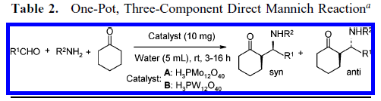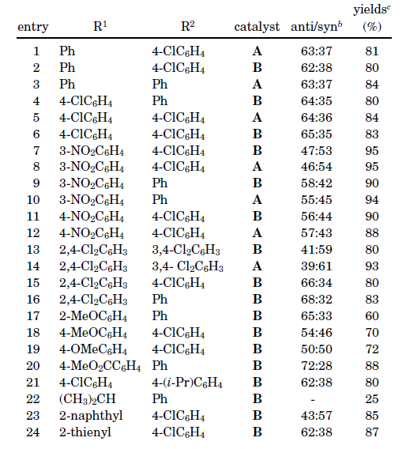 a Reaction conditions: aldehyde (3 mmol), amine (3.1 mmol), andcyclohexanone (5 mmol) were successively added to a solution of catalyst(10 mg) in water (5 mL) placed in a test tube, and the reaction mixture was vigorous stirred at room temperature for 3-16 h. b Yields of isolated products. c Diastereomeric ratio mearsured by 1H NMR spectroscopy analysis of the crude reaction mixture.
Another characteristic feature of the present protocol is the high chemoselectivity of cyclohexanone toward aldimines,prepared in situ from the reaction of aldehydes andamines, in preference to aldehydes as shown in Scheme 2.
Although conventional Lewis acids activate aldehydes preferentially, in this media, aldehydes do not undergo aldol reaction by means of HPAs in water. The high chemoselectivityis rationalized by considering the higher basicity of nitrogen over oxygen. A related phenomenon was recently reported in the reactivity between aldimines and aldehydes by the use of proline, HBF4, and dibutyltin dimethoxide.11 In conclusion, this procedure offers several advantages including low loading of catalyst, improved yields, clean reaction, use of unmodified ketones, which make it a useful and attractive strategy for the multicomponent reactions of combinational chemistry. In addition, a very easy workup has been realized that does not require organic solvents.
When the products are solid and insoluble in water, the pure products can be obtained directly by filtration and washing the filtrate with water and by crystallization from ethanol or diethyl ether. No extraction or separation by column chromatography is necessary in some cases. Current efforts attempting to expand the application of heteropoly acids in water for other reactions.
References:- A (1)New Investigation of Mannich Reaction.Li Yuan MOU2, Zi Yun LIN1, Li Ya ZHU1*, Xiao Tian LIANG11Institute of Materia Medica, Chinese Academy of Medical Sciencesand Peking Union Medical College, Beijing 100050
2Center for Biophysical Science and Engineering University of Alabama
at Birmingham 901 14th street South, Birmingham, AL 35294 Chinese Chemical Letters Vol. 12, No. 6, pp. 471 – 474, 2001, (2)Mannich-Type Reactions of Aldehydes,Amines, and Ketones in a ColloidalDispersion System Created by a Brønsted Acid-Surfactant-Combined Catalyst in Water Kei Manabe and Shu Kobayashi*
Graduate School of Pharmaceutical Sciences, The UniVersity of Tokyo, CREST, Japan Science and Technology Corporation (JST), Hongo, Bunkyo-ku,Tokyo 113-0033,japan:Email: skobayas@mol.f.u-tokyo.ac.jp Received October 3, 1999 organic 1999 vol.1,no.12 1965-1967
(3) Application of High Pressure Induced by Water-Freezing to the Direct
Catalytic Asymmetric Three-Component List-Barbas-Mannich Reaction
Yujiro Hayashi,*,† Wataru Tsuboi,† Mitsuru Shoji,† and Noriyuki Suzuki|
Department of Industrial Chemistry, Faculty of Engineering, Tokyo UniVersity of Science, Kagurazaka,Shinjuku-ku, Tokyo 162-8601, Japan, and RIKEN, 2-1 Hirosawa, Wako, Saitama 351-0198, Japan
Received July 14, 2003; E-mail: hayashi@ci.kagu.tus.ac.jp
(4) Highly Efficient One-Pot Three-Component Mannich Reaction in
Water Catalyzed by Heteropoly Acids.
Najmodin Azizi, Lalleh Torkiyan, and Mohammad R. Saidi*
Department of Chemistry, Sharif UniVersity of Technology, P.O. Box 11465-9516,Tehran 11365, Iran saidi@sharif.edu Received February 28, 2006.organic letters 2006 vol.8,no.10 2079-2082

